3.60: a) This may be done by a direct application of the result of Problem 3.59; with 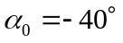, substitution into the expression for x gives 6.93 m.
b)
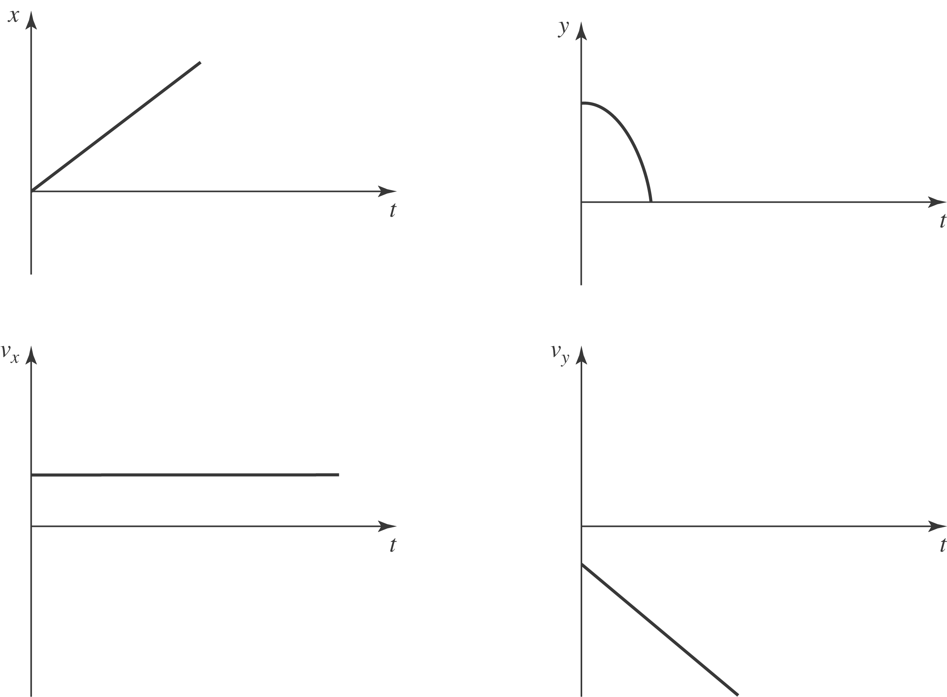
c) Using 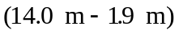 instead of h in the above calculation gives 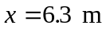, so the man will not be hit.

